1. Start a new vagrant instance by running `vagrant up` and wait forever 😊
2. `vagrant ssh`
3. Let’s first install two namespaces for Prometheus and Jaeger

kubectl create namespace monitoring

kubectl create namespace observability

1. For installing both Jaeger and Prometheus, we need to install helm first

curl https://raw.githubusercontent.com/helm/helm/master/scripts/get-helm-3 | bash

1. Now, we need to add both Jaeger and Prometheus repositories to Helm and update it

helm repo add prometheus-community [https:*//prometheus-community.github.io/helm-charts*](https://prometheus-community.github.io/helm-charts)

helm repo add stable [https:*//charts.helm.sh/stable*](https://charts.helm.sh/stable)

helm repo add jaegertracing <https://jaegertracing.github.io/helm-charts>

helm repo update

1. Now, let’s install Prometheus in monitoring namespace and verify it

helm install prometheus prometheus-community/kube-prometheus-stack --**namespace** monitoring --kubeconfig /etc/rancher/k3s/k3s.yaml

kubectl get pods -n monitoring

1. You can use this to access the Prometheus UI

kubectl port-forward service/prometheus-operated --address 0.0.0.0 9090:9090 -n monitoring

1. You can use this to access Grafana UI via its service

kubectl port-forward svc/prometheus-grafana --address 0.0.0.0 3000:80 -n monitoring

1. Now, let’s install Jaeger in observability namespace

kubectl **create** -**n** observability -**f** https://**raw**.githubusercontent.com/jaegertracing/jaeger-**operator**/**master**/deploy/service_account.yaml

kubectl **create** -**n** observability -**f** https://**raw**.githubusercontent.com/jaegertracing/jaeger-**operator**/**master**/deploy/**role**.yaml

Run modified role-binding.yaml and jaeger-operator within project files to watch all namespaces and be able to see default namespace:

kubectl **create** -**n** default -**f** role-binding.yaml

kubectl **create** -**n** observability -**f** **jaeger-operator**.yaml

kubectl **create** -**f** https://**raw**.githubusercontent.com/jaegertracing/jaeger-**operator**/**master**/deploy/cluster_role.yaml

kubectl **create** -**f** https://**raw**.githubusercontent.com/jaegertracing/jaeger-**operator**/**master**/deploy/cluster_role_binding.yaml

1. Now, we can create a Jaeger Instance in a jaeger.yaml file then apply it in default namespace because our app we want to trace is in default namespace. First move to manifests folder and apply jaeger.yaml.

cd project-folder/manifests/jaeger-custom

apiVersion: jaegertracing.io/v1

kind: Jaeger

metadata:

name: jaeger-instance

kubectl apply -f jaeger.yaml -n default

1. Now, we need to check if everything is there and the screen should be similar to what you see below the command

kubectl get -n observability pods,svc

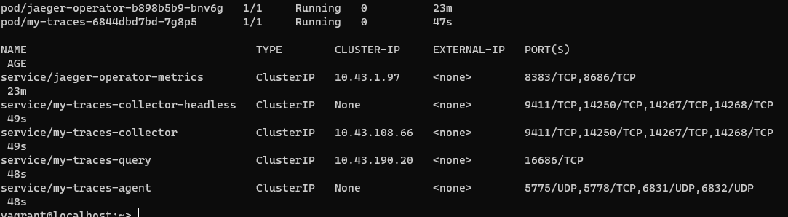

1. Go to the project folder and apply backend, frontend and trial services in default namespace

kubectl apply -f app/

1. We can run port-forward on Jaeger query UI to make sure that it is properly installed and go to localhost:16686 . Keep it open and start the next step in the new terminal tab

kubectl port-forward service/jaeger-instance-query --address 0.0.0.0 16686:16686